EE 564-REPORT OF PROJECT 3

A-Traction Motor Design

Ali GEZER – 1876135

Contents

INTRODUCTION 3

Analytical Section 3

The Main Dimensions 3

Winding Selection 5

Electric and Magnetic Circuit 6

Compulational Section 8

RMxprt Analysis 8

Torque-Speed Characteristics 8

Current waveforms at rated conditions 9

Efficiency curves 9

Equivalent circuit parameters 10

Effect of skewing 10

FEA Analysis in Maxwell-2D 11

CONCLUSION 16

Notes 16

# INTRODUCTION

In this project, it is asked to design and analyze a traction asynchronous squirrel cage induction motor (with copper rotor-bars) with the following specifications:

* Rated Power Output: 1280 kW
* Line-to-line voltage: 1350 V
* Number of poles: 6
* Rated Speed: 1520 rpm (72 km/h) (driven with 78 Hz inverter)
* Rated Motor Torque: 7843 Nm
* Cooling: Forced Air Cooling
* Insulating Class: 200C
* Train Wheel Diameter: 1210 mm
* Maximum Speed: 140 km/h
* Gear Ratio: 4.82

In the first part; the motor parameters (main dimensions, material properties, mechanical frame size, magnetic circuit parameters, electric circuit parameters, rough thermal calculations, efficiency, current, torque characteristics, mass calculations) are given corresponding to analytical calculations. On the other hand, some computational outputs of the RMxprt tool and the 2D FEA-Maxwell belong to the modeled motor with calculated analytical parameters are given in the second part. At last, not only the comparison of the analytical and computational results, but also general design considerations are investigated.

# Analytical Section

## The Main Dimensions

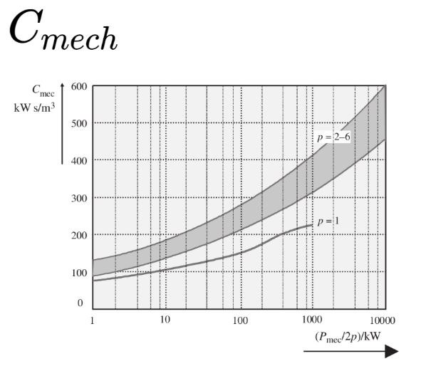Firstly, let’s choose the specific machine constant (Cmech), which depends on the electrical and magnetic loading using the Figure 1.

Considering to be in the interval, Cmech is chosen as;

|  |  |
| --- | --- |
| **Ppole((Pmec/2p)/kW)** | 213,3333333 |
| **Cmech(kW.s/m^3)** | **250** |

Figure 1

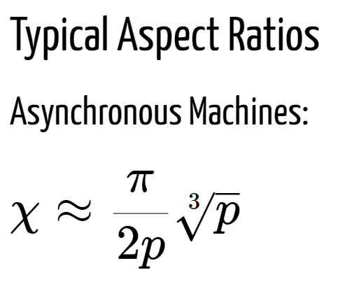Then, using the following formulas, we can calculate stator inner diameter and effective length:

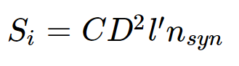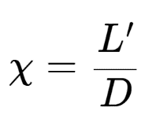

|  |  |
| --- | --- |
| **n-sync(synchronuous rotor speed in Hz)=f/p** | 26 |
| **X-Aspect ratio** | 0,754777275 |
| **D-stator inner diameter(m) = (Pmech/(Cmech.X.nsync))^(1/3)** | **0,638987848** |
| **L'-Effective Length(m)** | **0,482293507** |

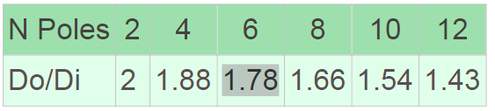After having the inner stator diameter-D, we can calculate the outer stator diameter using the information in Table 1:

Table 1

|  |  |
| --- | --- |
| **Do-stator outer diameter(m) = 1,78*D** | **1,137398369** |

At this point it is important to check whether the tip speed is in the acceptable range or not;

|  |  |
| --- | --- |
| **nmax(rpm)=nrated*(Vmax/Vrated)** | 2955,555556 |
| **Tipspeed(m/s)=2*pi*(D/2)*(nmax/60)** | **98,83485374** |

Since resulting Tip Speed is ~99, it is acceptable (< 100 m/s). Then, we can go on with calculating the airgap length with using the following information;

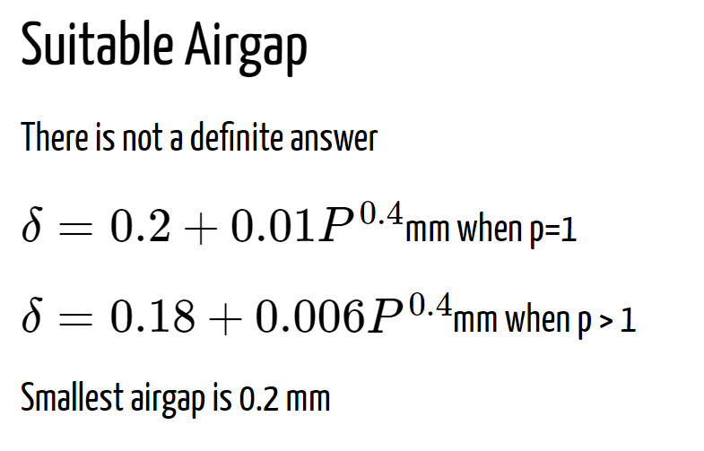

|  |  |
| --- | --- |
| **δ = Lairgap(mm) =0,18+0,006.Pmech^0,4** | 0,284962759 |
| **δ = Lairgap(mm) - smallest airgap** | **2** |

Since calculated airgap is smaller than 2 mm, which is smallest airgap due to the mechanical constraints, the airgap length is determined as 2 mm.

## Winding Selection

In order to select the winding, it is needed to determine the Number of Stator Slots and check the compatibility of slot pitch with the following information;

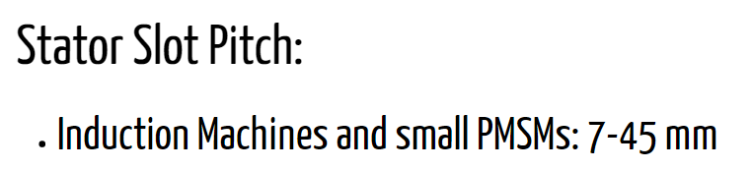

Considering to have integral winding, qs-the number of slots per pole per phase is assumed as 3 and the following calculations are conducted accordingly.

|  |  |
| --- | --- |
| **m - number of phases** | 3 |
| **qs - Number of Slots per pole per phase** | 3 |
| **Qs - Stator Slot Number = 2p * m * qs** | **54** |
| **Stator Slot Pitch (mm) = (2*pi*(D/2))/Qs** | **37,15596005** |

Notice that, Stator Slot Pitch is acceptable (7< 25.76 <45).

|  |  |  |  |  |  |
| --- | --- | --- | --- | --- | --- |
| **n - harmonic number** | 1 | 3 | 5 | 7 | 9 |
| **coil pitch(in elect rad) = (8/9)*pi** | 2,791111111 | 2,791111111 | 2,791111 | 2,791111 | 2,791111 |
| **kp -pitch factor = sin( (n*coil-pitch)/2)** | 0,98468459 | -0,86496168 | 0,640072 | -0,33736 | -0,00637 |
| **a - angle between each coil(in elect rad)**  **= pi/(qs*m)** | 0,348888889 | 0,348888889 | 0,348889 | 0,348889 | 0,348889 |
| **kd-distribution factor**  **= sin(qs*(n*a/2))/(qs*sin(n*a/2))** | 0,95983542 | 0,666973126 | 0,218149 | -0,17683 | -0,33333 |
| **kw - winding factor** | **0,945135147** | **-0,57690619** | **0,139631** | **0,059656** | **0,002124** |

Let’s choose 8/9 under pitched coil-double layer winding. Then, resulting winding factors are calculated corresponding to harmonic number as;

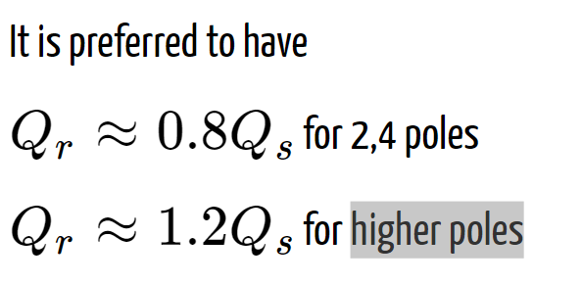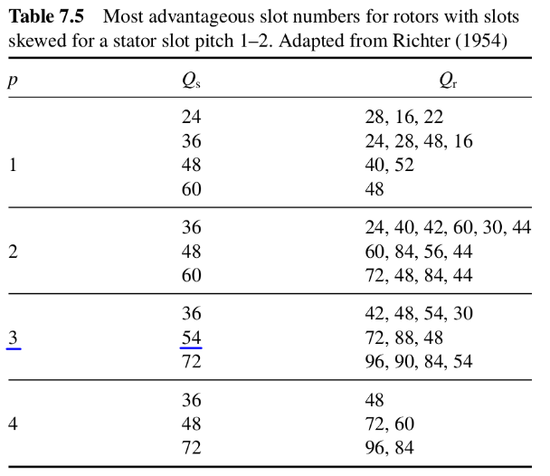Notice that 8/9 under pitched coil eliminates the 9th harmonic as expected.

Also, we can determine the number of rotor slots using the above information and the Table 2. Since, we have 6 poles, we should have Qr >Qs. Also, 72/54~1.33 is closer to 1.2 than 88/54~1.63 .Therefore, Qr is selected as 72.

Table 2

|  |  |
| --- | --- |
| **Qr - Rotor Slot Number (72 or 88)** | **72** |

## Electric and Magnetic Circuit

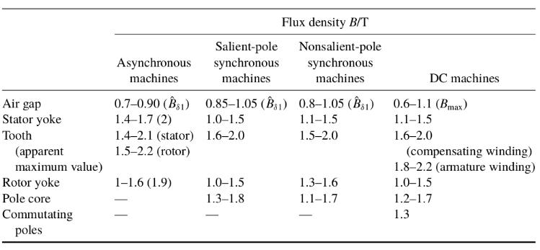In the Table 3, typical flux density values are given. Using this information, we can select an acceptable value for peak airgap flux density = 0.8 T.

Table 3

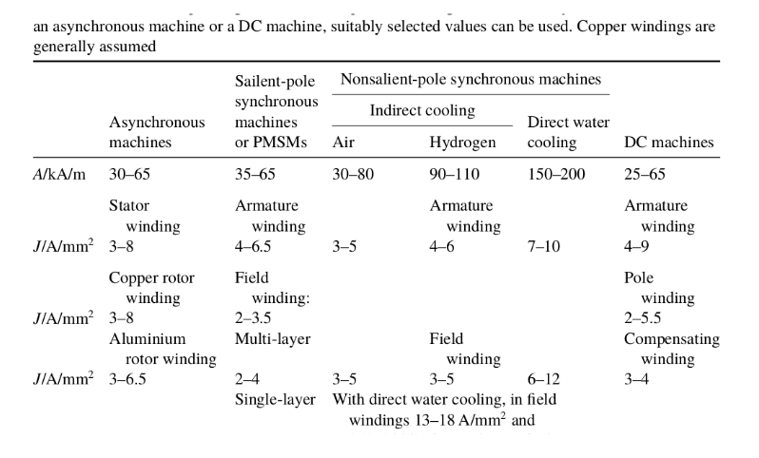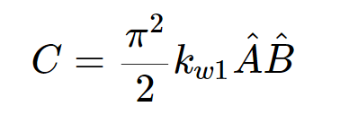Then, using the equation on the right side, we can obtain also electric loading since winding factor and Cmech have already be known.

Table 4

|  |  |
| --- | --- |
| **B^ - peak airgap flux density (T)** | **0,8** |
| **A - linear curr density(kA/m) = Cmech*(2^0,5)/(pi^2*kw1*B^)** | **47,42548812** |

Notice that the current density value is acceptable (30 < 47.43 < 65) as can be seen in the Table 4.

Now, we can determine the winding turns as:

|  |  |  |
| --- | --- | --- |
| **Em - EMF value = 0,98*(V/(3^0,5))** | **935,5022715** |  |
| **w - angular electrical speed = 2*pi*f** | **489,84** |  |
| **Stator Pole Pitch,PP (m) = (Stator Slot Pitch* qs * m)/1000** | **0,33440364** |  |
| **ai -coeff of arithmetic average of the flux density of one pole=2/pi** | 0,636942675 |  |
| **Ns - # of coil t.s in sers in a ph = (2^0.5)*Em/(w*kws*L`*PP*ai*B^)** | 34 | **36** |
| **zq - # of conductors per slot = (2*1*m*Ns)/Qs** | 3,777777778 | **4** |
| **Resulting B^ (T)** | **0,772727599** |  |

Since we have double layer winding, zq should be an even integer number. Therefore, Ns is rounded to an appropriate number (=36), and resulting peak airgap flux density is calculated. Notice that 0.77 T is also a proper value for peak airgap flux density.

Again using Table 3, we can select peak stator teeth flux density = peak rotor teeth flux density = 1.7(T). Using this, we ca determine the stator and rotor teeth width as;

|  |  |
| --- | --- |
| **B^st (T) - peak stator teeth flux density** | 1,7 |
| **kFe - space factor of the iron** | 1 |
| **L - Real Length(m) ~ L`** | 0,482293507 |
| **bds - stator teeth width(mm) = (L`*SP*B^)/(kFe * L * B^st) + 0.1** | **17** |
| **Rotor Slot Pitch,RSP (mm) = (2*pi*(D/2))/Qr** | **27,86697004** |
| **B^rt (T) - peak rotor teeth flux density= B^st (T)** | 1,7 |
| **bdr - rotor teeth width(mm) = (L`*RSP*B^)/(kFe * L * B^rt) + 0.1** | **13** |

Notice that the teeth width values are rounded considering production tolerances.

Before determination of other slot dimensions, we need to find the necessary area in a slot considering the current and the current density. Then, we can determine slot dimensions assuming 95% efficiency and 0.8 pf;

|  |  |
| --- | --- |
| **eff** | 0,95 |
| **pf** | 0,8 |
| **Is (A)- Stator current = (Pmech*1000/3) / ((V/(3.0^0.5))*eff*pf)** | 720,2810376 |
| **Ir (A)- Rotor current = zq*Qs*Is*0.9/(4*Qr)** | 486,1897004 |
| **J (A/mm^2)** | 4 |
| **Acs(mm^2) - Stator conductor area = Is/(4*J)** | 45,01756485 |
| **Acr(mm^2) - Rotor conductor area = Ir/(4*J)** | 121,5474251 |
| **awg-8 current rating (A)** | 75 |
| **A-awg8 (mm^2)** | 8,3 |
| **Nawg8 - Number of needed awg8 = Is/awg-8 current rating** | 10 |
| **Space factor coeff** | 0,7 |
| **Ass (mm^2) - Area of stator slot = A-awg8*Nawg8*zq/Spacefactor** | 474,2857143 |
| **Ars (mm^2) - Area of rotor slot = Acr** | 121,5474251 |
| **Stator slot width,SSW(mm) = SP-bds** | **20,15596005** |
| **Rotor slot width,RSW(mm) = RSP-bdr** | **14,86697004** |
| **Stator slot depth,SSD(mm) = Ass/SSW** | **23,53079253** |
| **Rotor slot depth(mm) = Ars/RSW** | **8,175668934** |

Having all this information, we can determine inner rotor diameter and a more accurate value for Do-outer diameter for stator selecting a proper value for yoke flux densities from the Table 3:

|  |  |
| --- | --- |
| **B^sy (T) - peak stator yoke density** | 1,5 |
| **B^ry (T) - peak rotor yoke density** | 1,2 |
| **App (m^2)- Area per pole = L`*D*pi/(2p)** | 0,161280704 |
| **Flux per pole = App * B^** | 0,124626051 |
| **Do(mm) = ((Fluxperpole/2)/(L`*B^sy))+(D+SSD)** | **748,6529479** |
| **Dir(mm) = (D-RSD)-((Fluxperpole/2)/(L`*B^ry))** | **523,1442949** |

# Compulational Section

## RMxprt Analysis

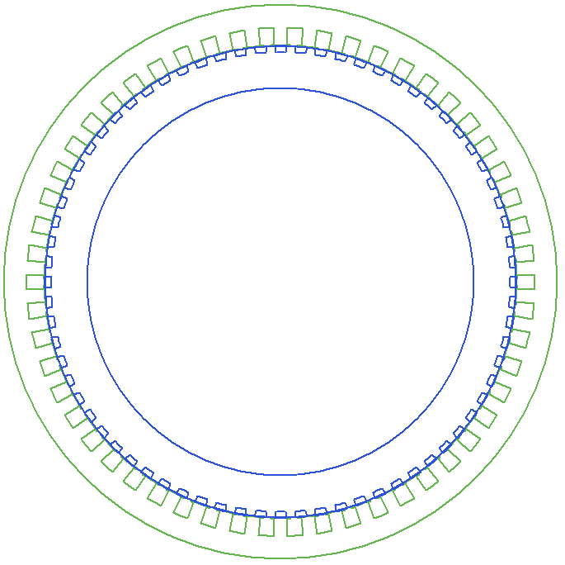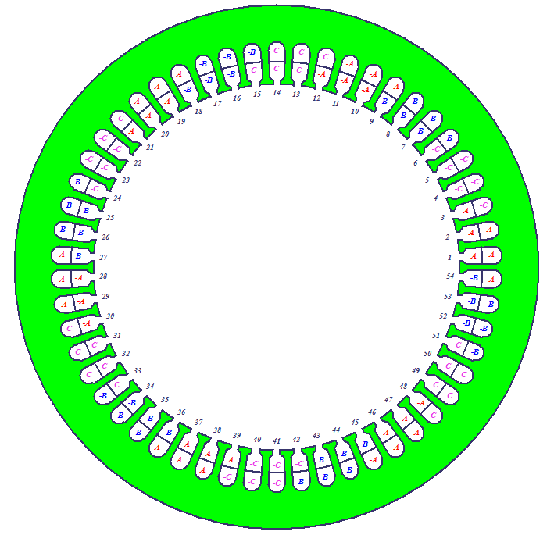 The Design Sheet (Output.pdf) obtained from the RMxprt tool is attached.

Figure 3: Main Machine Model

Figure 2: Winding of the Model

### Torque-Speed Characteristics

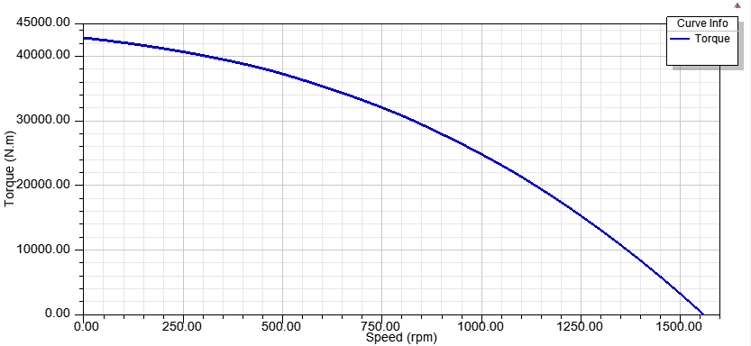

### Current waveforms at rated conditions

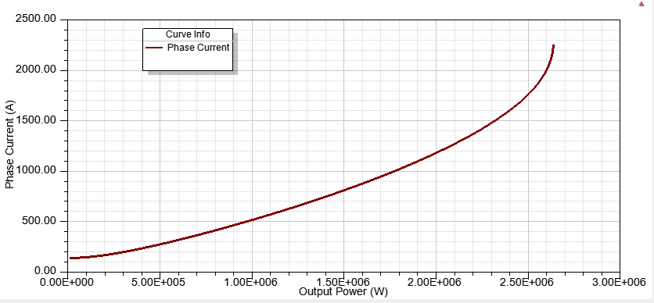

### Efficiency curves

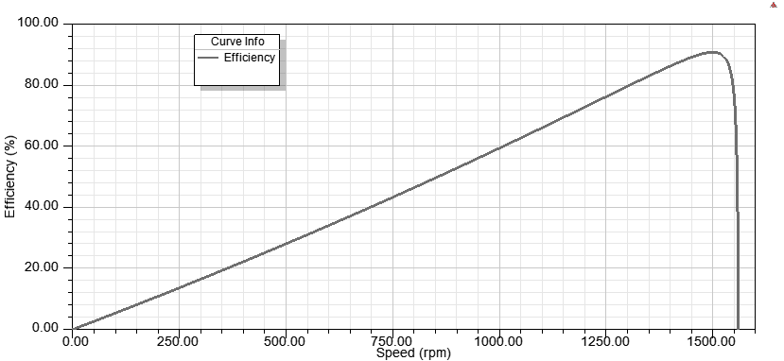

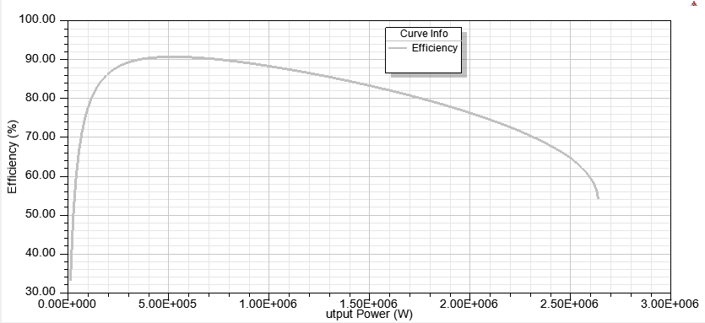

### Equivalent circuit parameters

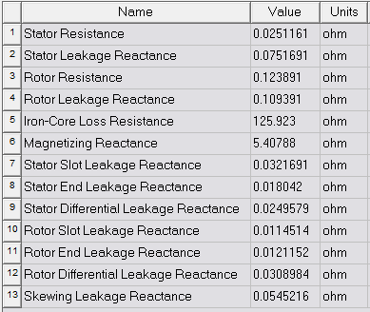

### Effect of skewing

Note that skew width is 2*RSP(rotor slot pitch) = 55.72 mm.

Skewing provides to avoid the cogging phenomenon and harmonics. With a skewed construction of rotor, magnetic locking or strong coupling of the machine may be prevented. Increase on rotor resistance may be considered as another effect of skewing. Thanks to this increase, starting torque of the machine may be improved.

## FEA Analysis in Maxwell-2D

In Figure 4 & 5 shows the magnetic flux density magnitudes and vectors. It can be seen that the magnitude of flux density in stator yoke is a bit higher than the analytically calculated value. At some points, even light yellow color can be seen. Note that for the time 0.048 s, the current and voltage waveforms are reached to steady state.

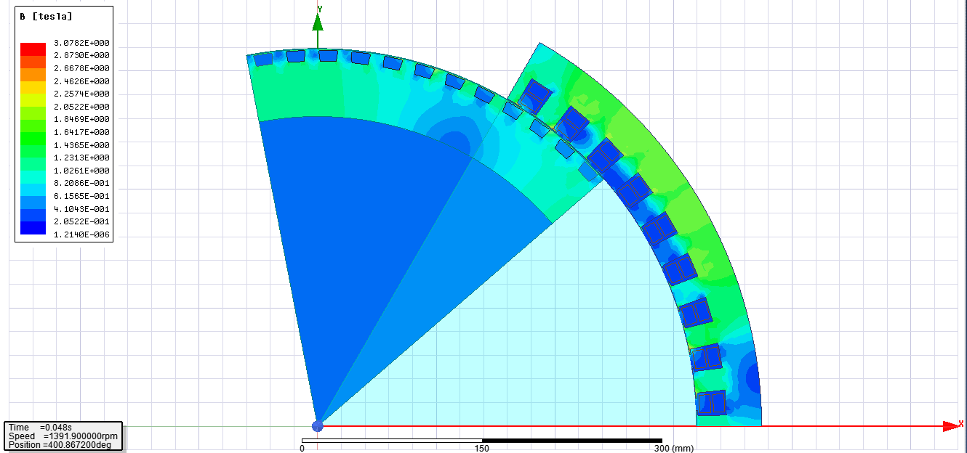

Figure 4

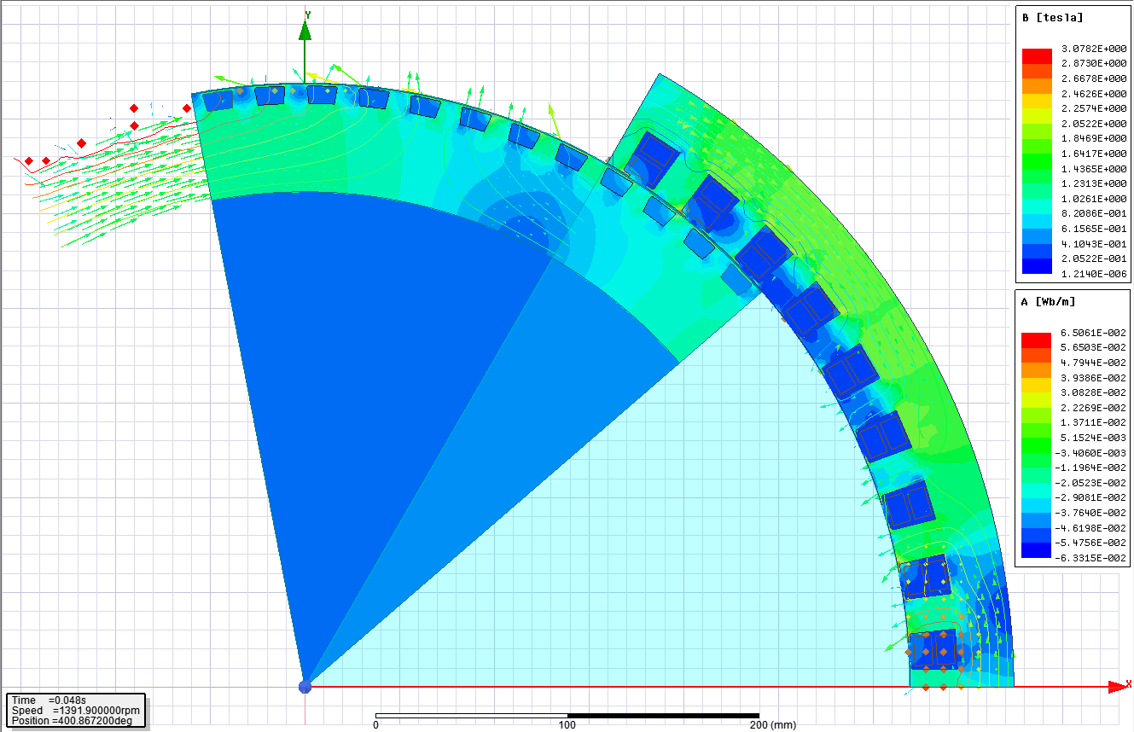

Figure 5

Since stator yoke flux density is a bit higher than the acceptable values, a second iteration was conducted to get more proper design increasing stator outer diameter from 748.65 mm to 770 mm. The results of the second iteration can be seen in the following figures. Notice that the figures corresponds to the same time, 0.048 s.

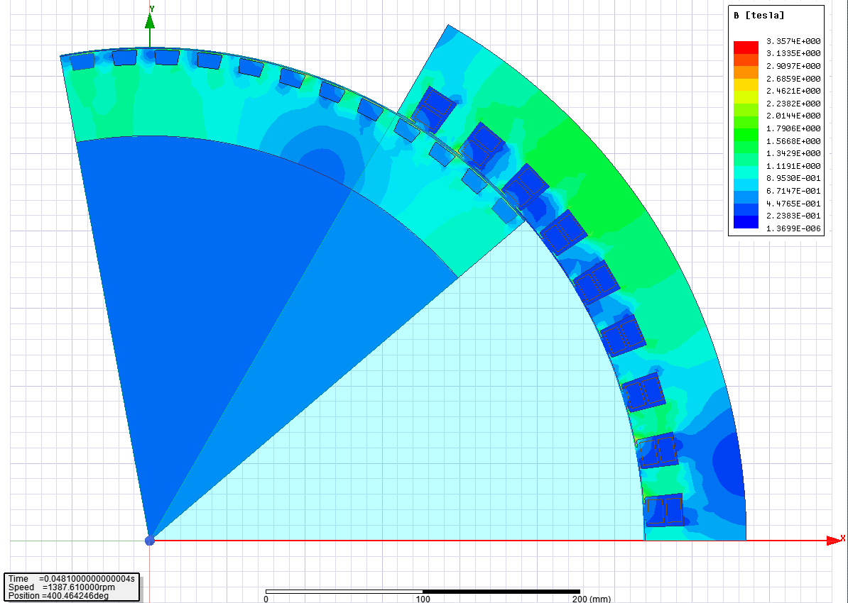

Figure 6

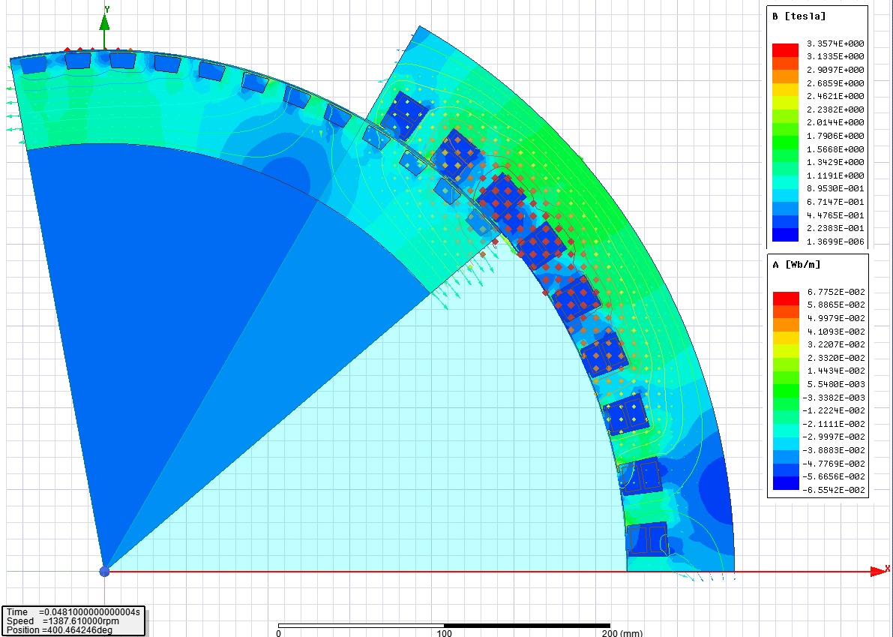

Figure 7

Notice that Figures 6 & 7 shoes that the peak stator yoke flux density is reduced (no more any yellow color) in the second iteration and efficiency is improved almost 1% (from ~85 to ~86).

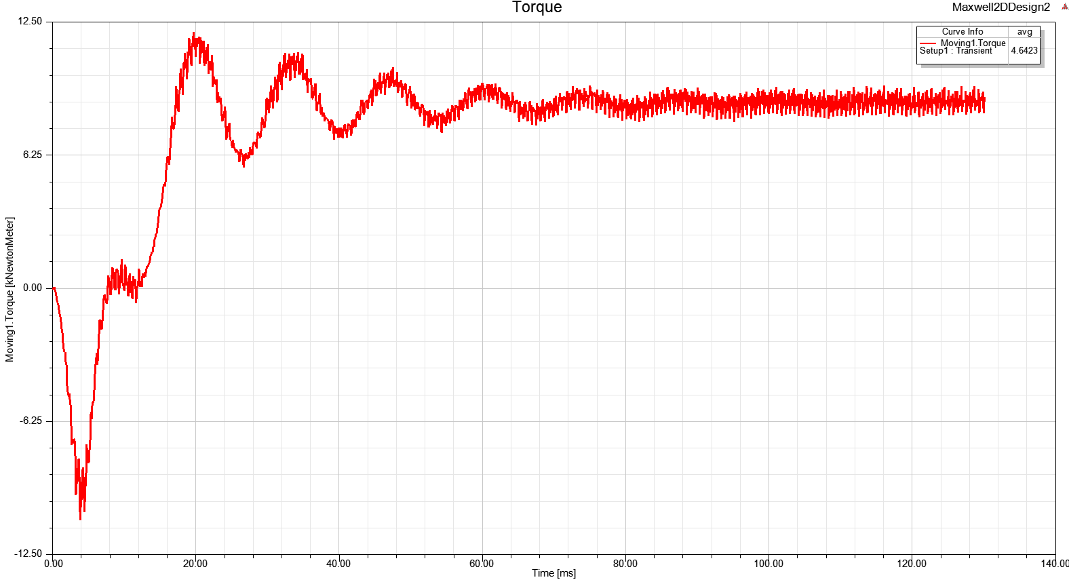

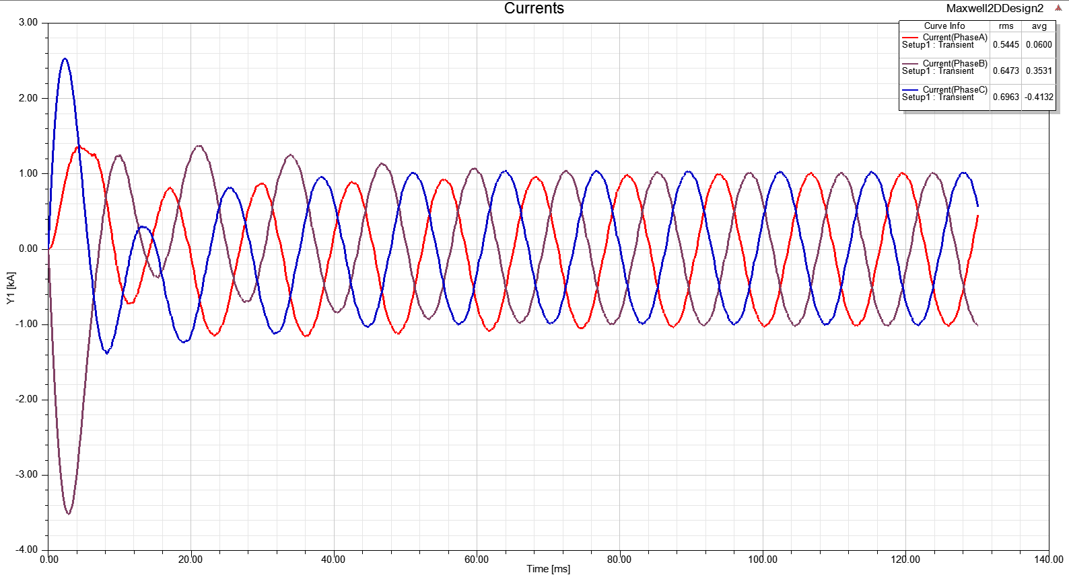

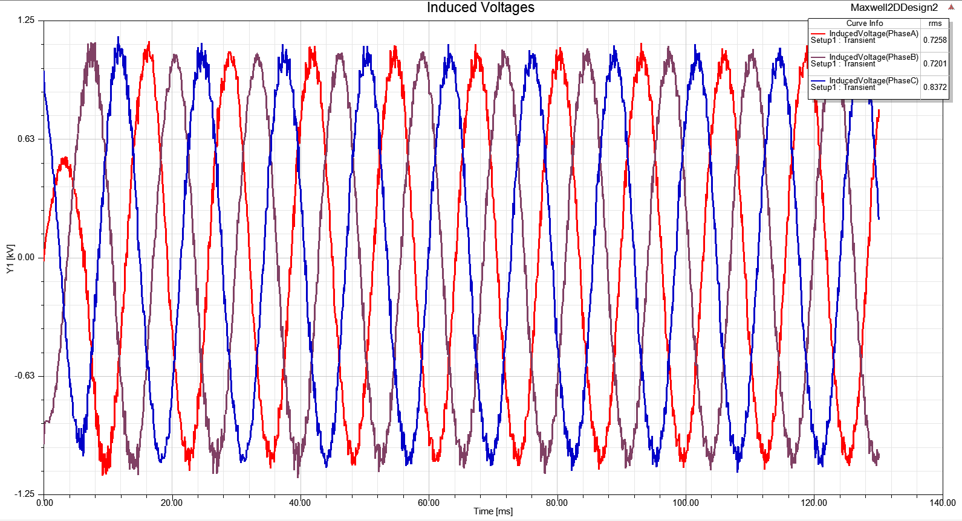 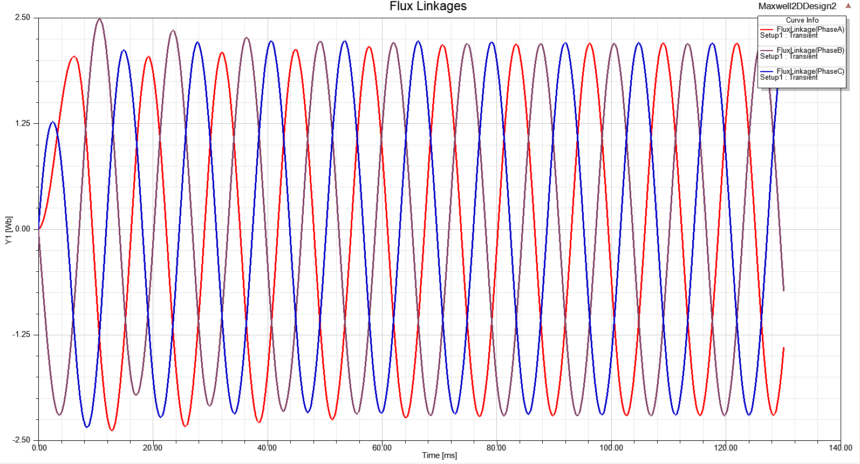 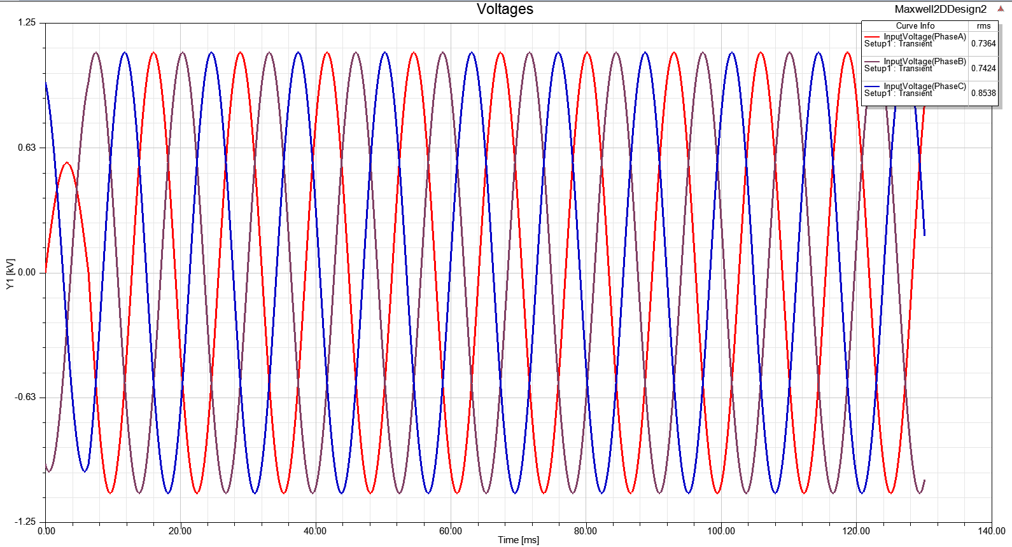 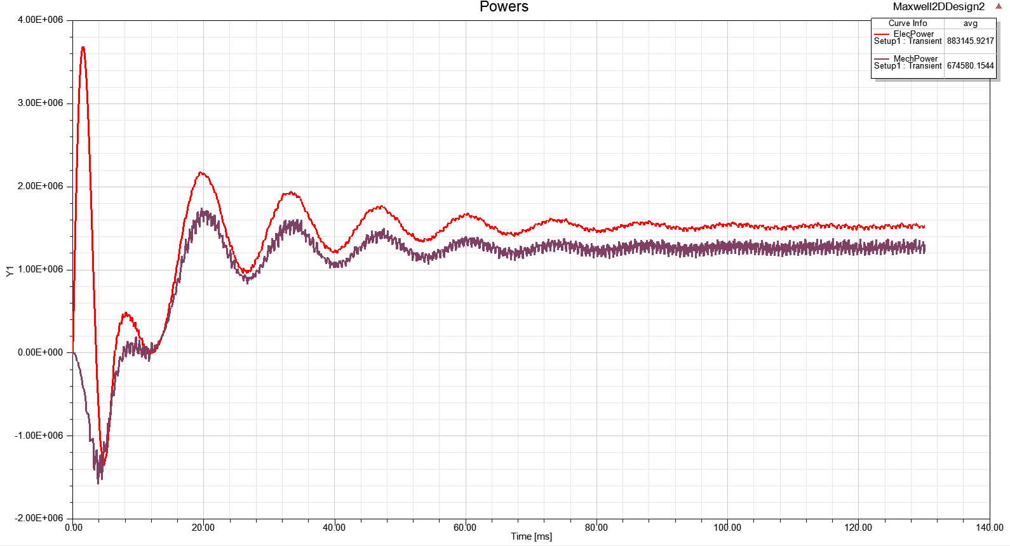

# CONCLUSION

In the analytical design part, the main design parameters are calculated using given information and general rules for good machine design. Using all of the parameters as input, RMxprt model of the machine is obtained and analysis on this tool is obtained. Although the results of RMxprt analysis are consistent with analytical calculations pretty much, the stator yoke flux density result were obtained a bit higher. Therefore, the efficiency was also lower than the analytically calculated value. Without any change, the RMxprt model was exported to FEA-2D analysis and, it was observed that the stator yoke was forcing for saturation with a value, higher than 2 T. Then, a second iteration was conducted increasing the stator outer diameter in RMxprt tool. In addition, the FEA analysis of the second iteration was obtained and, some improvements on peak stator yoke flux density and on efficiency were observed.

In conclusion, it is a good way of machine design that some analytical calculation with acceptable approximations may be conducted in order to get a rough input set for machine design. Then, using computational tools, the analytical inputs should be verified and the design should be improved/optimized with further iterations. Notice that, since we have so many approximation and assumption (eddy currents, fringing effects, etc.) on analytical calculations, it is expected to have some distinctness between computational and analytical analysis. However, the computational tools give more realistic analysis.

# Notes

All analytical calculations can be found in the attached excel file (P3_analytical calculations_vX.xlsx).

All computational tool files (corresponding to first and second iterations) can be found in the uploaded related files.